MY SQL QUIERES

Car Sales Analysis Project

CONVERT DATE (Date) COLUMN TO PROPER DATE FORMAT
update car_sales
set Date = str_to_date(Date,'%d-%m-%Y');

Data type of different Column
Describe car_sales ;

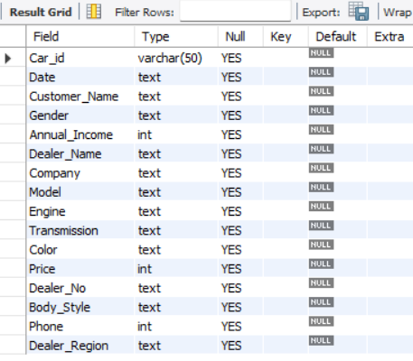

CHANGE COLUMN NAME `ï»¿transaction_id` to transaction_id
Alter table car_sales change column `ï»¿Car_id` Car_id varchar(50);

Total Sales
SELECT CONCAT(ROUND(SUM(Price)/1000000,2),"M") as Total_sales FROM car_sales;
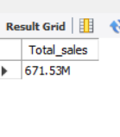

TOTAL SALES KPI – YOY Growth & YOY DIFF & MTD SALES & MONTLY SALES

YoY Growth
SELECT YEAR(Date) AS year,
CONCAT(ROUND(SUM(Price)/1000000,2),"M") AS total_sales,
(SUM(Price) - LAG(SUM(Price), 1)
OVER (ORDER BY YEAR(Date))) / LAG(SUM(Price), 1)
OVER (ORDER BY YEAR(Date)) * 100 AS YOY_growth_percentage
FROM
car_sales WHERE
YEAR(Date) IN (2022,2023)
GROUP BY YEAR(Date)
ORDER BY year(Date);

EXPLAINATION:
SELECT clause:
• YEAR(Date) AS year
- Reason: Extracts the year from the Date column.
- Shows results separately for 2022 and 2023.
• CONCAT(ROUND(SUM(Price)/1000000, 2), "M") AS total_sales
- SUM(Price): Calculates the total sales amount for each year.
- /1000000: Converts total sales into millions.
- ROUND(..., 2): Rounds the value to 2 decimal places for readability.
- CONCAT(..., "M"): Adds “M” to clearly show the number is in millions.
- Renames the final value as total_sales.
• (SUM(Price) - LAG(SUM(Price), 1) OVER (ORDER BY YEAR(Date))) / LAG(SUM(Price), 1) OVER (ORDER BY YEAR(Date)) * 100 AS YOY_growth_percentage
- LAG(SUM(Price), 1): Retrieves the previous year’s total sales.
- SUM(Price) - LAG(...): Calculates the difference between current year and previous year sales.
- Dividing by previous year's sales → gives growth rate.
- 100: Converts the growth rate into percentage.
- Renamed as YOY_growth_percentage (Year-over-Year growth).
FROM clause:
• car_sales
- The table from which yearly sales data is retrieved.
WHERE clause:
• YEAR(Date) IN (2022, 2023)
- Filters records and includes only transactions that occurred in the years 2022 and 2023.
GROUP BY clause:
• YEAR(Date)
- Groups data year-wise so that total sales and growth calculations are performed for each year separately.
ORDER BY clause:
• YEAR(Date)
- Sorts the final output in ascending order (2022 first, 2023 next).

Business Insight:
• Helps compare annual sales performance between 2022 and 2023.
• YoY growth percentage indicates whether sales improved or dropped compared to the previous year.
• Useful for financial planning, forecasting, and evaluating business performance trends.
• Shows whether marketing strategies, pricing, or customer demand improved in 2023.
• Enables companies to identify strong or weak sales years and make data-driven improvements.

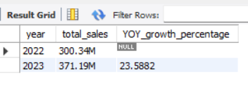

YOY DIFF
SELECT
YEAR(Date) AS YEAR,
ROUND(SUM(Price),1) AS total_sales,
(SUM(Price) - LAG(SUM(Price), 1) OVER (ORDER BY YEAR(Date))) as YOY_DIFF
FROM
car_sales
WHERE
YEAR(Date) IN (2022,2023)
GROUP BY
YEAR(Date)
ORDER BY
YEAR(Date);

EXPLAINATION:
SELECT clause:
• YEAR(Date) AS YEAR
- Extracts the year from each sales record.
• ROUND(SUM(Price), 1) AS total_sales
- Calculates the total yearly sales and rounds it to 1 decimal point.
• (SUM(Price) - LAG(SUM(Price), 1) OVER (ORDER BY YEAR(Date))) AS YOY_DIFF
- Compares current year sales with previous year sales to find the Year-over-Year difference.
FROM clause:
• car_sales
- Source table containing all car sales transactions.
WHERE clause:
• YEAR(Date) IN (2022, 2023)
- Filters data to include only records from these two years.
GROUP BY clause:
• YEAR(Date)
- Groups sales totals by year.
ORDER BY clause:
• YEAR(Date)
- Sorts results in ascending year order.

Business Insight
• Shows whether total annual revenue increased or decreased between 2022 and 2023.
• YOY_DIFF clearly highlights the absolute gain or drop in yearly sales value, helping identify performance trends.
• A positive YOY_DIFF signals business growth, likely due to higher demand, better pricing, or strong marketing.
• A negative YOY_DIFF would indicate declining sales, pointing toward market slowdown, inventory issues, or competition pressure.
• Perfect for Power BI cards, KPI visuals, and yearly comparison charts to support data-driven decision-making.

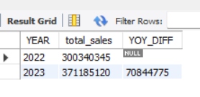

MTD TOTAL SALES
select
year(Date) as Year,
month(Date) as Month,
concat(round(sum(Price) / 1000000, 2), 'M') as MTD_Sales
from
Car_Sales
where
year(Date) = 2023 and month(Date) = 12
group by year(Date) , month(Date);

Explanation of the Query
SELECT clause:
• year(Date) as Year
- Extracts the year from each transaction date.
• month(Date) as Month
- Extracts the month number from the date.
• concat(round(sum(Price) / 1000000, 2), 'M') as MTD_Sales
- SUM(Price): Calculates total sales for the selected month.
- Divides by 1,000,000 to convert sales into millions (M).
- ROUND(..., 2): Keeps values to 2 decimal places.
- CONCAT(..., 'M'): Appends "M" to show the sales value in millions.
- Renames the result as MTD_Sales (Month-To-Date Sales).
FROM clause:
• Car_Sales
- The table where the sales data is stored.
WHERE clause:
• year(Date) = 2023 and month(Date) = 12
- Filters the data to include only sales from December 2023.
GROUP BY clause:
• year(Date), month(Date)
- Groups the results by year and month to calculate MTD sales for that specific month.

Business Insight
• Displays Month-To-Date (MTD) sales for December 2023, allowing the business to evaluate performance during one of the most crucial sales months.
• Helpful for understanding whether December is trending strong or weak compared to expectations or previous months.
• Useful for monitoring year-end sales momentum and planning marketing or discount strategies accordingly.
• MTD sales help leadership track real-time monthly performance, enabling quicker decision-making.
• Ideal for dashboards that show monthly KPIs, MTD vs Target comparison, or revenue tracking visuals.

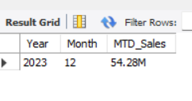

MONTLY TOTAL SALES
SELECT
SUM(price) AS Total_price, MONTH(Date) AS MONTH
FROM
car_sales
GROUP BY MONTH(Date);

EXPLAINATION:
SELECT clause:
• SUM(price) AS Total_price
Calculates the total sales amount for each month.
• MONTH(Date) AS MONTH
Extracts the month number from the Date column.
FROM clause:
• car_sales
This is the table from which the monthly sales data is retrieved.
GROUP BY clause:
• MONTH(Date)
Groups the results month-wise so that total sales can be calculated for each month separately.

Business Insight:
• Helps identify which months have the highest and lowest sales performance.
• Useful for understanding seasonal trends and demand fluctuations across the year.
• Helps the business plan marketing and inventory strategies based on month-wise sales patterns.
• Supports monthly performance tracking in dashboards and KPI scorecards.

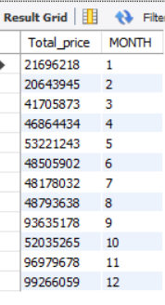

YTD TOTAL SALES
select
concat(round(sum(Price) / 1000000, 2), 'M') as YTD_sales
from
car_sales
where
year(Date) = 2023;

EXPLAINATION:
SELECT clause:
• concat(round(sum(Price) / 1000000, 2), 'M') as YTD_sales
SUM(Price): Calculates the total sales amount for the selected year.
Divides the value by 1,000,000 to convert it into millions (M).
ROUND(..., 2): Rounds the result to 2 decimal places for better readability.
CONCAT(..., 'M'): Adds "M" to indicate the sales value is in millions.
Renamed as YTD_sales (Year-To-Date Sales).
FROM clause:
• car_sales
The table from which the yearly total sales data is taken.
WHERE clause:
• year(Date) = 2023
Filters the data to include only the sales transactions that occurred in the year 2023.

Business Insight:
• Shows the total revenue generated in the current year, helping measure overall business performance.
• Useful for comparing actual YTD sales against yearly targets or previous years.
• Helps management understand growth pace and evaluate if the year is performing strong or weak.
• Supports KPI dashboards where yearly performance needs to be tracked continuously.

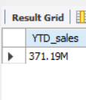

TOTAL AVG SALES KPI – AVG YOY Growth & AVG YOY DIFF & AVG MTD & AVG MONTHLY SALES

AVG YoY Growth
SELECT
YEAR(Date) AS YEAR,
ROUND(AVG(Price),1) AS total_sales,
(AVG(Price) - LAG(AVG(Price), 1)
OVER (ORDER BY YEAR(Date))) / LAG(AVG(Price), 1)
OVER (ORDER BY YEAR(Date)) * 100 AS AVG_YOY_increase_percentage
FROM
car_sales
WHERE
YEAR(Date) IN (2022,2023)
GROUP BY
YEAR(Date)
ORDER BY
YEAR(Date);

EXPLAINATION:
SELECT clause:
• YEAR(Date) AS YEAR
Extracts the year from the Date column for year-wise comparison.
• ROUND(AVG(Price),1) AS total_sales
Calculates the average sales price for each year.
Rounds the value to 1 decimal point for a clean output.
• (AVG(Price) - LAG(AVG(Price), 1) OVER (ORDER BY YEAR(Date))) / LAG(AVG(Price), 1) OVER (ORDER BY YEAR(Date)) * 100 AS AVG_YOY_increase_percentage
LAG(AVG(Price),1): Retrieves the previous year's average price.
AVG(Price) - LAG(...): Finds the difference between the current year's and previous year's average price.
Dividing by previous year average → gives percentage change.
*100 converts the result into percentage.
Renamed as AVG_YOY_increase_percentage (Average Year-over-Year Growth).
FROM clause:
• car_sales
Source table containing all sales and pricing information.
WHERE clause:
• YEAR(Date) IN (2022,2023)
Filters the data to include only the years being compared.
GROUP BY clause:
• YEAR(Date)
Groups the data year-wise to calculate each year’s average sales price.
ORDER BY clause:
• YEAR(Date)
Sorts the results in ascending order (2022 first, then 2023).

Business Insight:
• Helps understand how the average selling price has changed from one year to the next.
• A rising average price may indicate increased demand, premium models selling more, or price adjustments.
• A drop in average price may signal higher sales of lower-priced models or competitive pricing pressure.
• Useful for pricing strategy, profitability analysis, and monitoring yearly market trends.
• Supports dashboards that compare average sale values year over year.

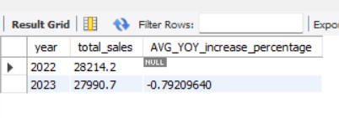

AVG YOY DIFF
SELECT
YEAR(Date) AS YEAR,
ROUND(AVG(Price),1) AS total_sales,
(AVG(Price) - LAG(AVG(Price), 1) OVER (ORDER BY YEAR(Date))) as AVG_YOY_DIFF
FROM
car_sales
WHERE
YEAR(Date) IN (2022,2023)
GROUP BY
YEAR(Date)
ORDER BY
YEAR(Date);

EXPLAINATION:
SELECT clause:
• YEAR(Date) AS YEAR
Extracts the year from each sales record for yearly comparison.
• ROUND(AVG(Price),1) AS total_sales
Calculates the average sales price for each year.
Rounds the value to 1 decimal place for clarity.
• (AVG(Price) - LAG(AVG(Price), 1) OVER (ORDER BY YEAR(Date))) AS AVG_YOY_DIFF
LAG(AVG(Price),1): Retrieves the previous year's average price.
AVG(Price) - LAG(...): Calculates the difference between current year and previous year average price.
Renamed as AVG_YOY_DIFF (Average Year-over-Year Difference).
FROM clause:
• car_sales
The table from which all yearly price and sales data is taken.
WHERE clause:
• YEAR(Date) IN (2022,2023)
Filters the data to only include these two years for comparison.
GROUP BY clause:
• YEAR(Date)
Groups sales data by year to compute yearly average price and YoY difference.
ORDER BY clause:
• YEAR(Date)
Sorts the output in ascending order (2022 first, then 2023).

Business Insight:
• Shows how much the average selling price has increased or decreased compared to the previous year.
• Helps identify pricing trends—whether customers purchased higher-priced models or lower-priced ones.
• Useful for understanding market shifts, purchasing patterns, and model mix changes.
• Supports profit analysis since changes in average price directly impact revenue margins.
• Helpful for dashboards comparing yearly price differences and price sensitivity.

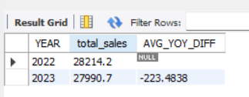

MTD(MONTH TO DATE) AVG SALES
SELECT
AVG(Price)/1000 AS AVG_MTD_sales
FROM
car_sales
WHERE
YEAR(Date) = 2023;

EXPLAINATION:
SELECT clause:
• AVG(Price)/1000 AS AVG_MTD_sales
AVG(Price): Calculates the average sales price for the selected period.
Divides the value by 1000 to convert it into thousands (K).
Renamed as AVG_MTD_sales (Average Month-To-Date Sales).
FROM clause:
• car_sales
The table from which the average sales data is taken.
WHERE clause:
• YEAR(Date) = 2023
Filters the data to include only the sales transactions from the year 2023.

Business Insight:
• Shows the average revenue contribution per transaction for the current year-to-date period.
• Helps monitor how average sales value is trending within the year.
• Useful for comparing with previous months or previous years’ averages.
• Supports assessing customer buying power and price sensitivity.
• Ideal for dashboards showing MTD average revenue or YTD pricing trends.

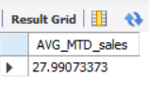

AVG MONTLY SALES
SELECT
MONTH(Date)AS MONTH,ROUND(AVG(price),2) AS Avg_Total_sales
FROM
car_sales
GROUP BY MONTH(Date);

EXPLAINATION:
SELECT clause:
• MONTH(Date) AS MONTH
Extracts the month number from the Date column for monthly analysis.
• ROUND(AVG(price),2) AS Avg_Total_sales
AVG(price): Calculates the average sales price for each month.
ROUND(..., 2): Rounds the value to 2 decimal places for clarity.
Renamed as Avg_Total_sales.
FROM clause:
• car_sales
The table from which the monthly average sales data is taken.
GROUP BY clause:
• MONTH(Date)
Groups the records month-wise to calculate the average sales for each month.

Business Insight:
• Helps understand how the average selling price changes across different months.
• Useful for identifying seasonal pricing trends—months with higher or lower average transaction values.
• Helps evaluate the impact of promotions, discounts, or festivals on monthly average sales.
• Supports pricing strategy decisions and monthly revenue planning.
• Ideal for line charts or monthly KPI visuals in dashboards.

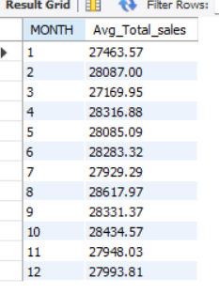

YTD AVG SALES
SELECT
CONCAT(ROUND(AVG(Price) / 1000, 2), 'K') AS AVG_Total_Sales
FROM
car_sales
WHERE
YEAR(Date) = 2023;

EXPLAINATION:
SELECT clause:
• CONCAT(ROUND(AVG(Price) / 1000, 2), 'K') AS AVG_Total_Sales
AVG(Price): Calculates the average sales price for the selected year.
Divides the value by 1000 to convert it into thousands (K).
ROUND(..., 2): Rounds the result to 2 decimal places.
CONCAT(..., 'K'): Adds "K" to indicate the value is in thousands.
Renamed as AVG_Total_Sales (Year-To-Date Average Sales).
FROM clause:
• car_sales
This is the table from which yearly average sales data is retrieved.
WHERE clause:
• YEAR(Date) = 2023
Filters the data to include only sales transactions from the year 2023.

Business Insight:
• Shows the average transaction value customers paid during the year 2023.
• Helps understand customer spending patterns and the type of cars being purchased (premium vs. budget).
• Useful for comparing YTD average price against previous years to monitor pricing trends.
• Supports profitability analysis, as higher average selling price often indicates better margins.
• Ideal for dashboards that track average selling price KPIs throughout the year.

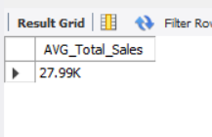

TOTAL COUNT CAR SOLD KPI – COUNT YOY Growth & COUNT YOY DIFF & COUNT MTD & COUNT MONTHLY SALES

Count YoY Growth
SELECT
year(Date) AS year,
ROUND(COUNT(Car_id),1) AS total_sales,
(COUNT(Car_id) - LAG(COUNT(Car_id), 1)
OVER (ORDER BY YEAR(Date))) / Lag(COUNT(Car_id), 1)
OVER (ORDER BY YEAR(Date)) * 100 AS Count_YOY_increase_percentage
FROM
car_sales
WHERE
YEAR(Date) IN (2022,2023)
GROUP BY
YEAR(Date)
ORDER BY
YEAR(Date);

EXPLAINATION:
SELECT clause:
• year(Date) AS year
Extracts the year from the Date column for year-wise analysis.
• ROUND(COUNT(Car_id),1) AS total_sales
COUNT(Car_id): Counts the total number of cars sold in each year.
Rounds the output to 1 decimal place.
Renamed as total_sales.
• (COUNT(Car_id) - LAG(COUNT(Car_id), 1) OVER (ORDER BY YEAR(Date))) / LAG(COUNT(Car_id), 1) OVER (ORDER BY YEAR(Date)) * 100 AS Count_YOY_increase_percentage
LAG(COUNT(Car_id),1): Retrieves the previous year's number of cars sold.
COUNT(Car_id) - LAG(...): Calculates the difference in units sold between current and previous year.
Dividing by previous year count gives percentage change.
*100 converts the value into YoY percentage.
Renamed as Count_YOY_increase_percentage.
FROM clause:
• car_sales
The table from which yearly total car count data is taken.
WHERE clause:
• YEAR(Date) IN (2022,2023)
Filters the records to include only the years 2022 and 2023.
GROUP BY clause:
• YEAR(Date)
Groups the data year-wise for calculating total count and YoY difference.
ORDER BY clause:
• YEAR(Date)
Sorts the results in ascending order (2022 first, then 2023).

Business Insight:
• Shows how the number of cars sold has increased or decreased from one year to another.
• Helps evaluate sales performance and customer demand trends.
• A rising YoY count indicates strong market growth or successful marketing strategies.
• A decline may signal weak demand, competitive pressure, or supply challenges.
• Useful for capacity planning, forecasting, and yearly sales comparison dashboards.

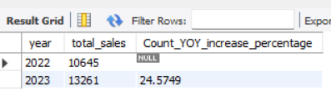

COUNT YOY DIFF
SELECT
YEAR(Date) AS YEAR,
ROUND(AVG(Price),1) AS total_sales,
(COUNT(Car_id) - LAG(COUNT(Car_id), 1) OVER (ORDER BY YEAR(Date))) as COUNT_YOY_DIFF
FROM
car_sales
WHERE
YEAR(Date) IN (2022,2023)
GROUP BY
YEAR(Date)
ORDER BY
YEAR(Date);

EXPLAINATION:
SELECT clause:
• YEAR(Date) AS YEAR
Extracts the year from the Date column for year-wise analysis.
• ROUND(AVG(Price),1) AS total_sales
Calculates the average price of cars sold in each year.
Rounds the value to 1 decimal place for readability.
Renamed as total_sales.
• (COUNT(Car_id) - LAG(COUNT(Car_id), 1) OVER (ORDER BY YEAR(Date))) AS COUNT_YOY_DIFF
COUNT(Car_id): Total number of cars sold in the current year.
LAG(COUNT(Car_id),1): Retrieves the previous year’s car count.
COUNT(Car_id) - LAG(...): Finds the difference in car units sold between the current year and previous year.
Renamed as COUNT_YOY_DIFF (Count Year-over-Year Difference).
FROM clause:
• car_sales
The table from which yearly sales and count information is taken.
WHERE clause:
• YEAR(Date) IN (2022,2023)
Filters the data to include only the sales records of the years 2022 and 2023.
GROUP BY clause:
• YEAR(Date)
Groups the dataset year-wise to calculate average price and unit difference.
ORDER BY clause:
• YEAR(Date)
Sorts the results in ascending order for clean yearly comparison.

Business Insight:
• Shows how many more (or fewer) cars were sold compared to the previous year.
• Helps identify whether demand is increasing or decreasing annually.
• Useful for operational planning—higher counts may require more inventory and manpower.
• A positive YoY difference indicates growth in customer interest and sales volume.
• A negative difference alerts management to declining performance or market slowdowns.

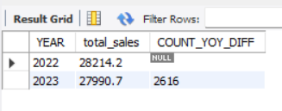

COUNT OF MTD(MONTH TO DATE) SALES
SELECT
COUNT(Car_id) AS COUNT_MTD_sales
FROM
car_sales
WHERE
YEAR(Date) = 2023 and MONTH(Date) = 12;

EXPLAINATION:
SELECT clause:
• COUNT(Car_id) AS COUNT_MTD_sales
Counts the total number of cars sold in the selected month-to-date period.
Renamed as COUNT_MTD_sales.
FROM clause:
• car_sales
The table from which the MTD sales count is retrieved.
WHERE clause:
• YEAR(Date) = 2023 AND MONTH(Date) = 12
Filters the data to include only the car sales that occurred in December 2023.
Ensures the count represents Month-To-Date sales for December.

Business Insight:
• Helps understand total units sold in the current month, helping track monthly performance.
• Useful for comparing December sales with previous months to identify growth or decline.
• Supports operational planning—higher MTD counts indicate higher demand requiring more stock.
• Helps management monitor real-time sales progress during the ongoing month.
• Useful for dashboards showing monthly sales KPIs and sales pace.

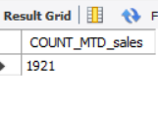

COUNT MONTLY SALES
SELECT
COUNT(Car_id) AS Total_car_sold, MONTH(Date) AS Month
FROM
car_sales
GROUP BY MONTH(Date);

EXPLAINATION:
SELECT clause:
• COUNT(Car_id) AS Total_car_sold
Counts the total number of cars sold for each month.
Renamed as Total_car_sold.
• MONTH(Date) AS Month
Extracts the month number from the Date column for month-wise analysis.
FROM clause:
• car_sales
The table from which the monthly car sales count is taken.
GROUP BY clause:
• MONTH(Date)
Groups the data month-wise so that total cars sold can be calculated for each month.

Business Insight:
• Shows the number of cars sold in each month, helping identify sales patterns across the year.
• Useful for detecting peak sales months and slow-moving periods.
• Helps in planning inventory, staffing, and marketing activities according to monthly demand.
• Supports forecasting and identifying seasonal trends in customer buying behavior.
• Ideal for dashboards analyzing monthly unit sales performance.

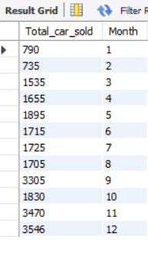

YTD CAR SOLD COUNT
SELECT
CONCAT(ROUND(COUNT(Car_id)/1000,2),"K") AS YTD_Total_car_sold
FROM
car_sales
WHERE
YEAR(Date) = 2023;

EXPLAINATION:
SELECT clause:
• CONCAT(ROUND(COUNT(Car_id)/1000,2),'K') AS YTD_Total_car_sold
COUNT(Car_id): Counts the total number of cars sold in the selected year.
Divides by 1000 to convert the value into thousands (K).
ROUND(...,2): Rounds the value to 2 decimal places for neat presentation.
CONCAT(...,'K'): Adds “K” to indicate the value is in thousands.
Renamed as YTD_Total_car_sold (Year-To-Date Total Cars Sold).
FROM clause:
• car_sales
The table from which the total number of cars sold in the year is retrieved.
WHERE clause:
• YEAR(Date) = 2023
Filters the data to include only the records from the year 2023.

Business Insight:
• Shows the total number of cars sold so far in the current year.
• Helps management evaluate annual performance and compare against previous years.
• Useful for assessing market demand and sales team effectiveness.
• Helps track progress toward yearly sales targets or company KPIs.
• Ideal for dashboards showing YTD unit sales and overall annual performance.

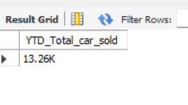

WEEKLY SALES (LINE CHART)
SELECT
WEEK(Date), SUM(Price) AS Total_Price
FROM
car_sales
WHERE
YEAR(Date) = 2023
GROUP BY WEEK(Date);

EXPLAINATION:
SELECT clause:
• WEEK(Date)
Extracts the week number from the Date column for weekly analysis.
• SUM(Price) AS Total_Price
Calculates the total sales amount for each week.
Renamed as Total_Price.
FROM clause:
• car_sales
The table from which the weekly sales data is taken.
WHERE clause:
• YEAR(Date) = 2023
Filters the records to include only the sales that occurred in the year 2023.
GROUP BY clause:
• WEEK(Date)
Groups the data week-wise to calculate total sales for each week.

Business Insight:
• Helps identify weekly sales trends and fluctuations within the year.
• Useful for monitoring short-term performance and spotting sudden increases or drops in sales.
• Supports weekly planning for marketing campaigns, inventory restocking, and sales strategies.
• Helps management track sales momentum throughout the year.
• Ideal for dashboards that display weekly KPIs or weekly revenue charts.

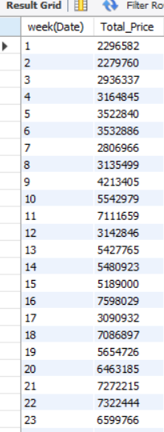
OR
SELECT
WEEK(Date) as WEEK,
SUM(price) AS TOTAL_SALES
FROM
car_sales
WHERE
WEEK(Date) = 2
GROUP BY WEEK(Date);
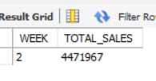

TOTAL SALES BY BODY STYLE (DONUT CHART)
SELECT
Body_Style,
SUM(Price) AS Total_Price,
ROUND((SUM(Price) / (SELECT SUM(Price) FROM car_sales WHERE YEAR(Date) = 2023)) * 100, 2) AS Percentage
FROM car_sales
WHERE YEAR(Date) = 2023
GROUP BY Body_Style
ORDER BY Percentage DESC;

EXPLAINATION:
SELECT clause:
• Body_Style
Retrieves the type of car body style (e.g., SUV, Sedan, Hatchback) for category-wise analysis.
• SUM(Price) AS Total_Price
Calculates the total sales amount generated by each body style.
Renamed as Total_Price.
• ROUND((SUM(Price) / (SELECT SUM(Price) FROM car_sales WHERE YEAR(Date) = 2023)) * 100, 2) AS Percentage
SUM(Price): Total revenue from each body style.
(SELECT SUM(Price)…): Subquery that calculates total sales in 2023 for all models.
Dividing both values gives the contribution percentage of each body style.
ROUND(...,2): Rounds the percentage to 2 decimal places.
Renamed as Percentage.
FROM clause:
• car_sales
The table from which body-style wise price and sales data is taken.
WHERE clause:
• YEAR(Date) = 2023
Filters the data to include only sales from the year 2023.
GROUP BY clause:
• Body_Style
Groups the data by each car body style to calculate total sales and percentage share.
ORDER BY clause:
• Percentage DESC
Sorts the output from the highest to lowest contributing body style.

Business Insight:
• Shows which body style contributes the most to total yearly sales.
• Useful for understanding customer preference trends (e.g., SUV vs Sedan demand).
• Helps manufacturers and dealers adjust stock, marketing focus, and promotional strategies.
• Identifies low-performing body styles that may require improved sales strategy.
• Supports decision-making for product mix optimization and revenue-driven planning.

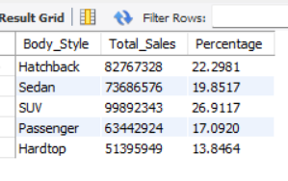

TOTAL SALES BY COLOR(Donut Chart)
SELECT
Color,
SUM(Price) AS Total_Sales,
(SUM(Price) / (SELECT
SUM(Price)
FROM
car_sales
WHERE
YEAR(Date) = 2023)) * 100 AS Percentage
FROM
car_sales
WHERE
YEAR(Date) = 2023
GROUP BY Color;

EXPLAINATION:
SELECT clause:
• Color
Retrieves the color of the car for category-wise sales analysis.
• SUM(Price) AS Total_Sales
Calculates the total sales amount generated by each car color.
Renamed as Total_Sales.
• (SUM(Price) / (SELECT SUM(Price) FROM car_sales WHERE YEAR(Date) = 2023)) * 100 AS Percentage
SUM(Price): Total revenue generated by each color.
(SELECT SUM(Price)…): Subquery that returns the total sales for the year 2023.
Dividing both values gives the percentage contribution of each color to the total yearly sales.
Renamed as Percentage.
FROM clause:
• car_sales
The table from which the color-wise sales data is retrieved.
WHERE clause:
• YEAR(Date) = 2023
Filters the data to include only the sales records for the year 2023.
GROUP BY clause:
• Color
Groups the data by color to calculate total sales and contribution percentage for each color.

Business Insight:
• Helps identify which car colors are most popular among customers.
• Useful for inventory planning—high-demand colors can be stocked more.
• Helps understand customer preferences and market trends by color category.
• Supports marketing and promotional strategies targeting popular or low-performing colors.
• Ideal for dashboards showing color-wise contribution to total sales.

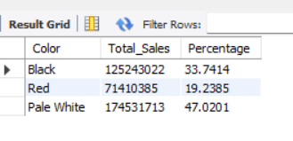

Company-Wise Sales Trend in Grid Form
SELECT
Company,
AVG(CASE WHEN YEAR(Date) = 2023 THEN Price END) AS YTD_car_avg,
COUNT(CASE WHEN YEAR(Date) = 2023 THEN Car_id END) AS YTD_car_count,
SUM(CASE WHEN YEAR(Date) = 2023 THEN Price END) AS YTD_sales,
(SUM(CASE WHEN YEAR(Date) = 2023 THEN Price END) -
SUM(CASE WHEN YEAR(Date) = 2022 THEN Price END))
/ NULLIF(SUM(CASE WHEN YEAR(Date) = 2022 THEN Price END),0) * 100 AS YOY_increase_percentage
FROM car_sales
WHERE YEAR(Date) IN (2022, 2023)
GROUP BY Company;

EXPLAINATION:
SELECT clause:
• Company
Retrieves the company/brand name to perform company-wise comparison.
• AVG(CASE WHEN YEAR(Date) = 2023 THEN Price END) AS YTD_car_avg
Calculates the average price of cars sold by each company in 2023.
Uses CASE to include only 2023 records.
Renamed as YTD_car_avg.
• COUNT(CASE WHEN YEAR(Date) = 2023 THEN Car_id END) AS YTD_car_count
Counts the number of cars sold by each company in 2023.
Counts only when the year is 2023.
Renamed as YTD_car_count.
• SUM(CASE WHEN YEAR(Date) = 2023 THEN Price END) AS YTD_sales
Calculates the total sales amount for each company in the year 2023.
Renamed as YTD_sales.
• (SUM(CASE WHEN YEAR(Date) = 2023 THEN Price END) - SUM(CASE WHEN YEAR(Date) = 2022 THEN Price END)) / NULLIF(SUM(CASE WHEN YEAR(Date) = 2022 THEN Price END),0) * 100 AS YOY_increase_percentage
SUM(CASE WHEN YEAR(Date)=2023…): Total sales for 2023.
SUM(CASE WHEN YEAR(Date)=2022…): Total sales for 2022.
Difference gives YoY sales change.
Dividing by 2022 sales gives growth percentage.
NULLIF avoids division by zero errors.
Renamed as YOY_increase_percentage.
FROM clause:
• car_sales
Source table containing company-wise sales and pricing data.
WHERE clause:
• YEAR(Date) IN (2022, 2023)
Filters the data to include only records from the years 2022 and 2023.
GROUP BY clause:
• Company
Groups all calculations company-wise so average sales, total sales, count, and YoY change are computed per company.

Business Insight:
• Shows how each company performed in terms of total sales, unit sales, and average selling price for 2023.
• Helps identify which company has grown the most compared to the previous year.
• Useful for competitive analysis—shows top-performing and underperforming companies.
• Helps understand which brands contribute most to overall revenue.
• Supports strategic decisions like targeting high-growth companies or improving performance of weaker ones.

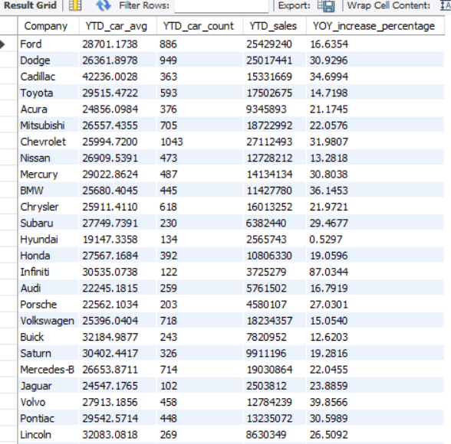
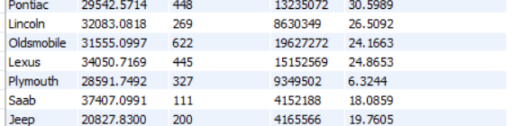

YTD TOTAL SALES BY MONTH
SELECT
MONTH(Date) AS Date, SUM(Price) AS Total_sales
FROM
car_sales
WHERE
YEAR(Date) = 2023
GROUP BY MONTH(date);

EXPLAINATION:
SELECT clause:
• MONTH(Date) AS Date
Extracts the month number from the Date column for month-wise analysis.
• SUM(Price) AS Total_sales
Calculates the total sales amount for each month.
Renamed as Total_sales.
FROM clause:
• car_sales
The table from which the monthly sales data is retrieved.
WHERE clause:
• YEAR(Date) = 2023
Filters the data to include only records from the year 2023.
GROUP BY clause:
• MONTH(Date)
Groups the data by month to calculate total sales for each month.

Business Insight:
• Shows month-wise revenue trend for the year 2023.
• Helps identify peak and low-performing months for sales.
• Useful for monitoring seasonal trends and planning marketing campaigns accordingly.
• Supports dashboards that track monthly total sales and trend analysis.
• Helps in inventory and resource planning based on monthly revenue patterns.

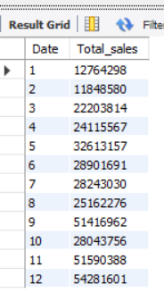
AVERAGE LINE
SELECT
AVG(Total_price) AS average_line
FROM
(SELECT
MONTH(Date) AS Month, SUM(Price) AS Total_price
FROM
car_sales
WHERE
YEAR(Date) = 2023
GROUP BY MONTH(Date)) t;
